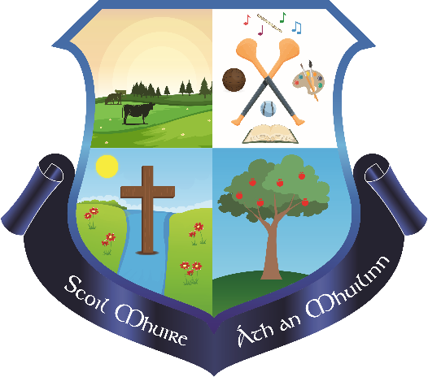

**March/April Newsletter**

**Scoil Mhuire Milford NS**

**Bí Cineálta:** The children have been coming up with their child friendly Anti Bullying posters and our winning poster will be on display throughout the school after Easter

**Autism Class:** The school has been sanctioned a new Autism Special Class for September. We are delighted with this new and very much looking forward to seeing the positive impact this will have on our school. This new class has resulted in the school gaining another permanent teacher and an SNA.

**First Confession:** 2nd class celebrated their Sacrament of Penance on Tuesday 25th February.

**Grandparents Day:** We celebrated Mass and a school visit for Grandparents Day on Thursday 27th February. It was fantastic to see all the visitors to the school and thank you to the Students Council and Parents Association for their help on the day.

We welcomed our **Religious Diocesan inspector** to the school on Wednesday 26th February.

**Solar Panels:** We have had our Solar panels installed since Monday 8th of March. As a result of this installation we have planted the equivalent of 41 trees due to our reduction in electrical demand.

**World Book Day** was celebrated in the school on Thursday 6th March

Congratulations to our students, Liam, Tadhg and Sarah for attending the **Primary games trials** held during the month of March

We started our school **GAA coaching** again in March with the help of Milford GAA. Thank you to the coaches Sean and Eoin for their time and expertise.

**1st/2nd Class attended a fun hurling/camogie blitz** in Ballyhea on Thursday 10th April. They also had some help from a few senior infants. Thank you to Ms. O’Gorman, Helen and Ms. Griffin for their help and to the parents who kindly offered to drive.

Our 5th and 6th class students competed in the **FAI 5 a side** competition in Banteer on Wednesday 12th March. One of our teams progressed to the county final which took place in Virgin Media Park on Wednesday April 2nd. The whole experience was fantastic for all students and some brilliant memories were made. Thank you to Ms. Keen and Margaret for their help.

5th and 6th class hosted a **Bake Sale** to raise funds for their Graduation events. This was extremely well organised and thank you to everyone who contributed to the event. Over €600 was raised.

The school has been notified of an **SPHE Department Inspection** on Wednesday 30th April and Thursday 1st May.

The **Free School Book Scheme** has been released in recent days and this will again result in parents not having to purchase books, workbooks and copies. We will be sending out booklists in the coming weeks.

The **Teacher allocation** for classes for next year will be released to parents following the Board of Management meeting on 15th May.

We celebrated **Wellbeing week** in the school from April 7th-11th. Thank you to Ms. o’Gorman, Ms. Healy, Sarah and the Wellbeing committee for their work in organising this.

The **Lunch Bag** has extended their services to now include fruit as a snack at small lunches. Children will now be getting apples/oranges each day as a snack at 11am.

**SSE (school self evaluation):** We are continuing with our targets for SSE this year. They include:

* Make school Assemblies at the end of each term a fixture in our school calendar
* Implement Bi Cinealta programme
* Re-establish a Green School Committee
* Have children engage with Maths Journals
* Achieve an Amber Flag for Wellbeing
* Promote the use of Gaeilge throughout the School.

**Upcoming Events/Dates;**

**Tuesday 29th April:** Hurling blitz for boys in 3rd-6th class in Ballyclough @10am. A bus is being used

**Thursday 8th May:** Open evening for new students from 6pm-7pm

**Wednesday 21st May:** School closing for full day to allow staff engagement with Code of Behaviour review, Child Protection and Subject planning

**Thursday 29th** May:Cork City Sports

**June 9th-13th:** Active Week

Children will also have Zumba, Rugby and Golf Lessons in the last term.

**June 10th:** Gaelbhratach representatives will collect an award in Roscrea 10am-14:00 pm.

**June 19th:** Sixth Class Graduation & End of year school mass 9:30 am.