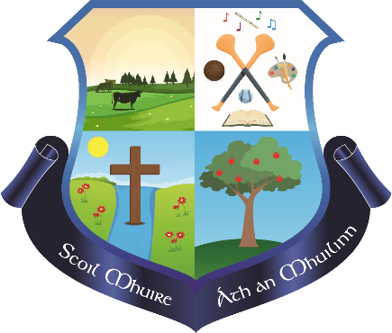

Scoil Mhuire Milford

Milford,

Charleville,

Co. Cork

17829E

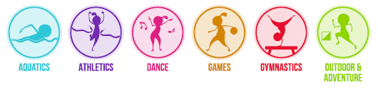

Physical Education Plan

Whole School Plan

Physical Education

Milford National School

**Introductory Statement**

This PE plan for Milford N.S. was formulated in consultation with the teachers and members of the Board of Management with the support of an Advisor for Physical Education from the Professional Development Service for Teachers.

**Rationale**

Physical Education provides children with learning opportunities through the medium of movement and contributes to their overall development by helping them to lead full, active and healthy lives. We aim to provide optimum learning opportunities for the children in our school by maximising active learning experiences and approaches which benefit each individual child.

**Vision**

Physical Education is distinguished from other curricular areas by its primary focus on the body and on physical experience and is an integral part of the educational process, without which the education of the child is incomplete. In Milford NS, by implementing a diverse range of experiences that provide regular, challenging physical activity, the balanced and harmonious development and general well-being of every child can be fostered.

Through our physical education programme, our children can experience the joy of physical exertion and the satisfaction of achievement while developing skills and positive attitudes that enhance self-esteem. Physical education provides opportunities to develop desirable personal and social attributes: the concept of fair play, the acceptance of success and failure, and the ability to cooperate in group situations. These opportunities contribute to the understanding and promotion of a healthy life-style. Physical education, as an integral part of the total curriculum, provides vital opportunities for the physical, social, emotional and intellectual development of the children in our school.

We aim to provide Physical Education opportunities which meet the physical needs of each child and their need for movement experiences, challenges and play. We aim to develop a desire for daily physical activity in all of the children through encouraging constructive and active use of free time, so that children will be motivated towards participation in physical activities in adult life. To fulfil these needs, our Physical Education programme is built on the principles of variety and diversity. We aim to provide a wide variety of movement activities appropriate to the level of development of each individual child.

**Aims**

We endorse the aims of the Primary School Curriculum for Physical Education[1]

* To promote the physical, social, emotional and intellectual development of the child
* To develop positive personal qualities
* To help in the acquisition of an appropriate range of movement skills in a variety of contexts
* To promote understanding and knowledge of the various aspects of movement
* To develop an appreciation of movement and the use of the body as an instrument of expression and creativity
* To promote enjoyment of, and positive attitudes towards, physical activity and its contribution to lifelong health-related fitness, thus preparing the child for the active and purposeful use of leisure time.

**Objectives of Physical Education**

The broad objectives of the PE curriculum have been considered in the design of this plan:

**Social and personal development**

* experience enjoyment and achievement through movement
* interact and cooperate sensitively with others, regardless of cultural or social background or special needs
* develop qualities of self-esteem, self-awareness, confidence, initiative and leadership through movement
* develop an understanding of fair play and team spirit through participation and competition
* develop positive attitudes towards participation in movement activities
* experience adventure and challenge

**Physical and motor development**

* develop strength, speed, endurance and flexibility through engaging in a wide variety of activities
* develop agility, alertness, control, balance and coordination through movement
* develop personal competence in the athletic skills of running, jumping and throwing
* perform dances with confidence and competence, including simple folk and Irish dances
* develop personal competence in a range of gymnastic movements
* develop personal competence in the games skills of sending, receiving and travelling using a variety of equipment, and to apply these skills in games situations
* apply the skills needed to live and move with confidence in the environment
* build water confidence near, in, on and under water
* develop personal competence in a variety of strokes and water agility

**Knowledge and understanding**

* develop an understanding and general knowledge of movement activities and derive benefit as a participant and as a spectator
* develop an understanding of travel and weight-bearing as the basis of efficient body management and control, both on the floor and using apparatus
* experience and develop an understanding of the use of space, speed, effort, direction and level in the performance of actions
* develop an understanding of the appropriate basic rules, tactics and strategies of movement activities
* observe, discuss, analyse, interpret and enjoy the performance of movement
* gather, record and interpret information on achievement in movement activities
* be inventive, make decisions, solve problems and develop autonomy through movement activities
* participate in and develop a knowledge, understanding and appreciation of cultural activities through movement
* develop an appreciation of and respect for the environment through participation in activities outdoors

**Creative and aesthetic development**

* use the body as a means of expression and communication, using a range and variety of stimuli
* create and perform simple dances
* create and play simple games
* develop artistic and aesthetic understanding within and through movement

**Development of health-related fitness**

* maintain and enhance health-related fitness through vigorous physical activity that helps to promote a healthy life-style
* understand and practice good hygiene and posture
* appreciate the benefits of relaxation and cope with challenges

**Development of safety**

* adopt safe practices in all physical activities

Curriculum Planning for Physical Education

**Physical Education**

**Athletics**

Running

Jumping

Throwing

Understanding and Appreciation of Athletics

**Games**

Sending, Receiving and Travelling,

Creating and Playing Games

Understanding and Appreciation of Games

**Dance**

Exploration and Creation and Performance of Dance

Understanding and Appreciation of Dance

**Aquatics**

Hygiene

Water Safety

Entry to/exit from the water

Buoyancy and propulsion

Stroke Development

Water-based ball games

Understanding and Appreciation of Aquatics

**Outdoor & Adventure Activities**

Walking

Orienteering

Outdoor Challenges

Understanding and Appreciation of O&A

**Gymnastics**

Movement

Understanding and Appreciation of Gymnastics

**The PE curriculum is organised into the six strands shown above. These strands and strand units can be found on the following pages of the** [**Physical Education Curriculum**](http://www.ncca.ie/uploadedfiles/Curriculum/PE_Curr.pdf)

* **Infant classes pp. 16-23**
* **First and Second classes pp. 24-34**
* **Third and Fourth classes pp. 38-46**
* **Fifth and Sixth classes pp. 48-59**
* **Aquatics: Third-Sixth pp.62-64**

In planning for teaching PE, teachers will be guided by the [PE Curriculum Teacher Guidelines](http://www.ncca.ie/uploadedfiles/Curriculum/PE_Gline.pdf) and will also use the PE lesson plans prepared by the Primary School Sports Initiative - [PSSI Lesson Plans](http://pssi.pdst.ie/clickme.html) and the PDST Move [Well, Move Often Physical Literacy Resource](https://www.scoilnet.ie/pdst/physlit/).

**Developing the Physically Literate pupil in Physical Education**

We use the **Move Well, Move Often** resource to support the teaching of Physical Literacy in Milford NS. Physical literacy is the underlying goal of all physical activity. Physical literacy addresses the whole child and respects each pupil as an individual. The physically literate child can be described as having the motivation, confidence, movement competence, knowledge and understanding to value and take part in physical activity throughout their personal lifelong journey. Physical literacy includes four essential and interconnected elements whose relative importance may change throughout life: Movement Competence, Motivation and Confidence, Knowledge and Understanding, and Opportunities to engage in physical activity for life.

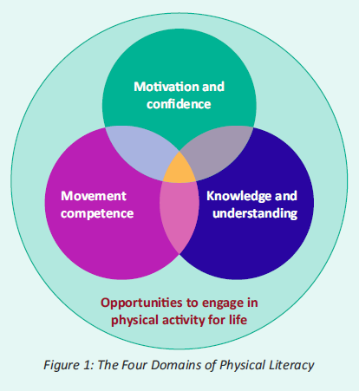

Physical Literacy gives pupils the tools they need to take part in physical activity and sport, both for healthy life-long enjoyment and for sporting success. To become physically literate, pupils need to master fundamental movement skills (FMS) through a series of developmental stages. FMS are the basic building blocks of movement and are an essential part of everyday life and recreational activity. It is only when these skills are mastered that a child can go on to develop specialised movement skills, which will allow them to reach their potential in sports-specific endeavours.

**Fundamental Movement Skills(FMS)**

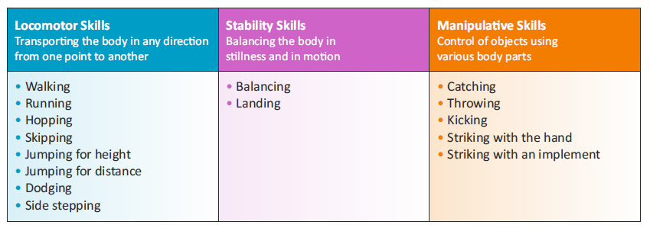

In Milford N.S., we recognise that it is important to teach a balanced range of locomotor, stability and manipulative skills across the strands during the year. Our whole school plan for PE reflects this approach.

Resources for Teaching Physical Education

Teachers in Milford N.S. will utilise the following core resources to support planning for and teaching a broad and balanced programme of Physical Education:

|  |  |  |  |
| --- | --- | --- | --- |
|  |  |  |  |
| Physical Education Curriculum | Physical Education Curriculum Teacher Guidelines | PSSI Lesson Plans | Move Well, Move Often Physical Literacy Resource |

**The role of the teacher is to**

* Help each child to develop a positive self-image and sense of fair play and cooperate with others.
* Ensure that the child experiences a variety of vigorous and challenging activities.
* Foster a stimulating and secure environment in which the child can be creative and imaginative.
* Link physical education activities with other curricular areas when appropriate.
* Evaluate the programme and assess the progress of each child.
* Provide information to parents, in line with school policy, about the class programme for physical education.
* Have due regard for safety by ensuring that each child adopts safe practices.
* Teachers will devise a balanced programme in line with this plan which meets the needs of each child in their class. Where possible, children will experience the following five strands each year – Athletics, Dance, Gymnastics, Games, Outdoor and Adventure Activities. Aquatics will be provided for a six week block from 3rd to 6th class.

Continuity and Progression

Teachers will ensure there is continuity and progression from class to class by

* Utilising appropriate warm-up activities relative to each class level.
* Following the structure of the PSSI lesson plans.
* Recording the content covered at each level in each strand (Cúntas Míosúil)

**Approaches and Methodologies**

Teachers will use a combination of the following teaching approaches**:**

* Direct teaching approach
* Guided discovery approach
* Integration

Teachers will use methodologies that encourage maximum participation by the child such as individual, pair, group and team work, station teaching or using a play area divided into grids.

**Structure of a PE lesson**

* Warm Up
* Main Activity– running, jumping, throwing, rolling, striking an object, kicking, playing small sided games, orienteering, dancing etc.

This main activity will take place at individual, pair and small group levels.

Station teaching will be used to teach a specific skill and to enable the children to experience a variety of activities in the PE lesson. We will divide the play area into grids to allow for small group activity and all children will be involved.

* Cool Down

**Multi-Class Teaching**

* Individual or partner work will be facilitated allowing for different activities appropriate to different stages of development using the same equipment and play area.
* Follow up activities to a basic lesson will be introduced where one group has an opportunity to practice again what was covered in the basic lesson while the other group moves ahead and develops further the content of the basic lesson.
* Group work will be facilitated through the station teaching method.
* Support personnel provided by sports, dance or gymnastics organisations will be used to help with group teaching, where necessary.

**Children with Different Needs**

In Milford N.S., we recognise that physical education is important in the curriculum for students with Special Educational Needs and disabilities. Pupils with special educational needs or disabilities depend on teachers to manage their learning and to provide support. In Milford NS, inclusive PE ensures that all pupils experience a sense of belonging during the lesson. This includes feeling respected, valued for who you are, and feeling a level of supportive energy and commitment from others. It is important to create and encourage a positive environment and to provide pupils with opportunities to enjoy physical activity with others, so that they will, in the future, approach activity as a means of socialisation and integration in the community.

Many children with SEN experience difficulty with basic coordination, balance, left and right orientation, rhythm, and spatial and body awareness. These skills can be addressed and improved through physical education. As it is a practical subject, it is particularly suited to the learning styles of many students with general learning disabilities. Students who experience difficulties and frustration in academic areas of their school life can enjoy and acquire personal achievement and satisfaction in the physical education curriculum. Physical education is a student-centred curriculum that challenges each student at his/her personal level. It is also a very sociable subject involving a high level of appreciation and acceptance of others.

Physical education can enable students with general learning disabilities to acquire and enjoy many physical skills during their school life, and so widen the possibilities for recreation and socialisation in their adult lives. It provides the student with an avenue to enjoy life and social interaction. All children will be encouraged to participate in all PE activities through the use of co-operative fun activities. We will provide encouragement and acknowledge good effort wherever possible. Our main aim is to set activities close to each child’s ability level but at the same time challenging them to improve their performance. Reasonable targets will be set for all children at individual, pair and small group levels. Teachers will endeavour to support and ensure the participation of children with Special Educational Needs and disabilities through an inclusive approach to planning for PE.

In order to make our PE curriculum inclusive and accessible, the following ideas may be considered when planning for inclusion of students with disabilities and Special Educational Needs:

* Skills, concepts and activities will need to be redefined and broken down into progressive stages to meet the varying abilities of these students.
* Learning expectations should be reasonable in meeting the balance between familiar and unfamiliar skills and activities.
* Realistic targets should be set, appropriate activities and equipment should be chosen, and sufficient time should be given to bridge the gap between applying familiar skills and learning and applying new skills and concepts.
* Positive reinforcement should be given frequently, the ability of the students should be emphasised, and appropriate activities should be provided in order to improve the self-esteem and confidence of these students.

The following support materials will assist teachers in planning for children with SEN and disabilities:

|  |  |  |  |  |
| --- | --- | --- | --- | --- |
|  |  |  |  |  |
| **PE guidelines for teachers of children with Mild GLD** | **PE guidelines for teachers of children with Moderate GLD** | **PE guidelines for teachers of children with Severe and Profound GLD** | **Special Olympics PE teaching resources** | **Best Start: Inclusive Schools Project** |

All pupils exhibit a wide range of abilities in the area of PE. Some may be talented, some may be gifted, while others show significant needs and require guidance through a progressive and systematic approach to their participation and learning. In planning for teaching this subject area, it is important to keep in mind the following key issues and learning difficulties that pupils may have.

**POTENTIAL AREAS OF DIFFICULTY FOR STUDENTS WITH MILD GENERAL LEARNING DISABILITIES**

|  |  |  |
| --- | --- | --- |
| **Potential area of difficulty** | **Implications for learning** | **Possible**  **Strategies** |
| • fitness levels | It may be necessary to set targets to improve fitness. | • include active warm ups and drills for skills practice  • vary activities in the lesson to include the use of gross motor skills; regular short periods of exercise daily; cooling down exercises and consultation with parents/guardians |
| • listening and responding | The student may have difficulty with short–term memory and concentration span. | • keep instruction simple and clear. Students repeat instruction.  • demonstration(s) of task; verbal analysis of task; student performs task; teacher affirms task  • move to new instruction regularly |
| • coordination and balance | The student may have difficulties in fine and  gross motor skills in all strand areas. | • teach suitable gait for skill, for example, throwing and catching a ball, jumping and landing, balancing.  • give good visual demonstrations  • reaffirm good examples and practices  • use additional equipment to suit the needs of the student, for example softer balls, larger target  • provide physical support to student in performing skill, for example, jumping |
| • spatial and body awareness | There may be safety issues for students engaging in movement exercises. | • provide suitable group arrangements; restrict area of movement; plan for the student to engage in follow the leader, and copying and contrasting exercises  • use specific body parts in exercises e.g make a shape with the upper part of the body |
| • left–right orientation | It may be necessary to include regular exercises with these movements. | • include warm-up exercises/stretches. Students mirror actions of peers or teacher: O’Grady says; Follow the leader  • include exercises with equipment using both sides of the body |
| • behaviour | This will necessitate the smooth  progression of lesson structure with clear instructions. | • establish routine format for class and the expectations of desired behaviours  • ensure that the student is suitably placed in the class for optimum learning  • check that the student is attending by reinforcing and questioning  • involve the student where possible in demonstration  • encourage the student and assign tasks opportunities for success |
| • Social integration. | Keep appropriate balance between cooperative and competitive activities. Foster enjoyment of activities with others. Encourage individual student’s interest in particular aspects of the strands. | • group student(s) appropriately  • use co-operative fun activities regularly  • give encouragement and acknowledge good effort  • set appropriate skill development level commensurate with students’ ability level  • set reasonable targets for co-operative activities (individual and group). |

**Exceptionally Able Children**

Children with exceptional ability or talent for PE will be encouraged and supported by acknowledging their talents and creating additional challenges for these children in the strands of the PE curriculum they excel in. These challenges will be based on the activity being pursued by the rest of the class. In addition, the children will be encouraged to maximise their talent by forging links with local clubs (if links have not been established already) so the child(ren) can progress their talent to a higher level. The children with exceptional ability will, on occasion, be encouraged to assist their classmates in achieving proficiency in the activities they are undertaking.

We will refer to the PE checklist in the NCCA Draft Guidelines for Exceptionally Able Students to identify children who have a special ability or talent for PE:

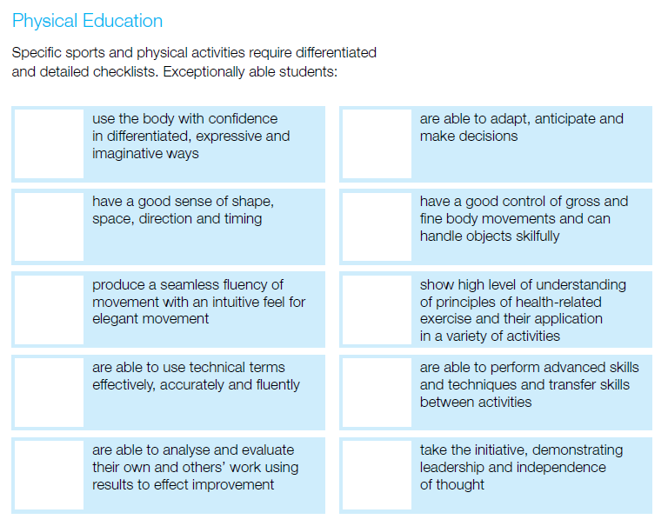

**Assessment and Record Keeping**

The teachers in the school constantly assess the PE lessons delivered as we identify progress and difficulties.

We will assess

* + Willingness to participate in activities
  + Readiness to engage with a certain activity
  + The level of competence of a child in carrying out an activity
  + Interest in and attitude to activity
  + Willingness to cooperate in individual, pair and group activities

Our assessment tools are:

* Teacher observation
* Teacher-designed tasks
* Move Well Move Often Assessment templates

Assessment is used to provide information on individual children, assist the teacher in planning a programme and facilitate communication with other teachers, parents and other professionals.

* **Assessment for learning** to provide feedback to children, improve learning and inform practice
* **Assessment of learning** which helps to identify the milestones children reach and the progress they make to report to parents, other teachers and the children themselves.
* **Assessment as learning** involves teaching the children how to self-assess and peer assess.

The assessment criteria used for each activity forms part of class and school planning.

*Assessment information is shared with parents at Parent Teacher meetings and in end-of-year school reports. The school will communicate home school link emails.If concerns are noted during the year parents may be contacted. Information is shared between teachers during the year as need arises and in particular in the case of formulating Individual Education Plans for children with special needs.*

**School Content and Equality of Participation and Access**

* We will endeavour to ensure that all children from infants to sixth class will partake in all six strands of the curriculum during their primary education. Aquatics will be provided for a six week block for 3rd to 6th class each year.
* We will provide equal access for all children to physical education equipment and facilities and the use of the playground during breaks will be incorporated as an integral part of the school’s programme. Our yard is divided into two sections for safety reasons. One part is for Juniors and Senior infants and the other section is for 1st and 2nd class. Likewise, when the senior end of the school is on yard 3rd and 4th class will play in one half of the yard while the other half will be used by 5th and 6th class. We will endeavour to have some PE equipment on the yard on different days for the classes eg: skipping ropes on a Friday and alternating the basketball court between classes on different days.
* On rainy days every effort will be made in the classroom to allow for physical activity. Our activities include disco breaks, 10@10, go noodle, bizzy breaks, chair yoga, cosmic yoga, cooperative games and classroom circuits.
* When grouping children for physical education the school will endeavour not to group children solely on the basis of gender whenever possible.
* As a staff we will help children to build positive attitudes towards all activities.
* We will consider the needs of girls and boys when promoting the health-related fitness of children.
* We will enter both boys’ and girls’ teams in inter-school competitions and where necessary (if we have insufficient numbers) we will take the opportunity to enter mixed teams.
* We will endeavour to celebrate multiculturalism through PE whenever possible, e.g. through including a variety of different types of folk dance or games from other countries, from time to time.
* **Cork City Sports Trials:** All children from Juniors to 6th are welcome to take part in the running trials. The children will run according to their age groups, not class groups. Children under seven will undertake a pre-trial. Junior and Senior Infant and 1st class teachers will explain clearly to the children that the pre-trials are not the final results. Those selected from the pre-trial will go forward to the trials for the under seven categories. The procedure for the trials will be explained to the children prior to the trials taking place. The procedure is as follows: the first race is a practice run. If a child falls in the actual run, the race will be run once more. If the result is unclear or there is a tie breaker the race will be run again.
* All children are encouraged to participate in school team sports. Selection of school teams are decided by the PE coordinator and teachers. While it is hoped that all children would get to participate, the management team will consider the following when selecting the team. This includes participation and interest shown at training sessions, level of ability and previous performances.
* Milford NS will send a representative to the Primary School Games if a child has the required skills and ability to meet the standard of this competition. Criteria for selection are based on performance at matches and school training. The decision for selection by the school management is final.
* Due to the increased enrolment of children from other countries in Irish schools, it is vital to help these children integrate. Physical education provides great opportunities for this integration.
* The Dance strand of the curriculum will be used to introduce dances from other cultures in the area of folk dance. The children from other countries will also appreciate the folk dances which are an integral part of our Irish culture.
* Large sporting events such as the Olympics, World Cup, Special Olympics etc will be used to look at the customs and sporting culture of some of the participating countries.
* Introduction of games from different countries, yet at the same time the school will acknowledge the special place that Gaelic Games holds in our culture. Gaelic Games should be given particular consideration as part of the Games programme**.**

In Milford NS,Mr.O’Flynn, Ms. Thompson and Ms. O’Gorman provide after school training in football and hurling for 3rd – 6th class throughout the year. Competitions such as the INTO Mini Sevens Hurling and Football,the Sciath na Scol Indoor Hurling and Camogie, Peil faoi Dhíon, Sciath na Scol one day blitzes in football, hurling and camogie,the Sciath na Scol Football and Hurling for both boys and girls will be entered every year to promote Gaelic Games in our school.

* We will provide for and include children experiencing any form of disadvantage.
* Every child will have access to all PE activities provided by the school and lack of financial resources on behalf of the child will not hinder their participation.

**Linkage and Integration**

Many of the broad objectives of PE, such as the development of self-esteem, confidence, cooperation and spatial awareness, are shared with other curricular subjects. Within PE, it is through learning opportunities provided in the various aspects of movement that these objectives can be achieved. The transfer and reinforcement of learning from other areas of the curriculum can be achieved when PE is integrated with other subjects. This approach can be particularly effective in meeting the needs of pupils with individual and varied learning styles, and enables pupils to appreciate how physical literacy is an integral part of all our lives.

**Language**

The effective use of questioning from the teacher will develop the vocabulary associated with physical education. Allowing the children to analyse and describe their own performance will allow them to understand and appreciate their learning in physical education.

**Content and Language Integrated Learning (CLIL)**

We will endeavour to use Gaeilge in our PE lessons when the opportunities arise throughout the lessons we teach. We will make every attempt to include language and content that we are teaching in other subjects into our PE lessons when we say the opportunity.

**Organisational Planning**

In this school all classes will timetable two 30-minute physical education lessons per week. Below is the grid of the strands and fundamental movement skills used for all classes in our whole school 2 year plan

|  |  |  |  |  |  |  |  |
| --- | --- | --- | --- | --- | --- | --- | --- |
| **YEAR 1 2022/23** | | | | | | | |
| **Term**  **1** | **Month** | **September** | **October** | | **November** | | **December** |
| **Strand** | **Games** | **Games** | | **Dance** | | **Dance** |
| **FMS** | **Throwing** | **Catching** | | **Skipping** | | **Sidestepping** |
| **Term**  **2** | **Month** | **January** | | **February** | | **March** | |
| **Strand** | **Gymnastics** | | **Gymnastics** | | **Athletics** | |
| **FMS** | **Balancing** | | **Landing** | | **Walking** | |
| **Term**  **3** | **Month** | **April** | | **May** | | **June** | |
| **Strand** | **Athletics** | | **Outdoor and Adventure** | | **Outdoor and Adventure** | |
| **FMS** | **jumping** | | **running** | | **striking** | |

* **Aquatics** is subject to pool timetabling for 3rd to 6th class. We will focus on the **FMS** of **‘kicking’** during this strand.

|  |  |  |  |  |  |  |  |
| --- | --- | --- | --- | --- | --- | --- | --- |
| **Whole School PE Plan – 2 year cycle** | | | | | | | |
| **YEAR 2 2023/24** | | | | | | | |
| **Term**  **1** | **Month** | **September** | **October** | | **November** | | **December** |
| **Strand** | **Games** | **Games** | | **Dance** | | **Dance** |
| **FMS** | **Hopping** | **Kicking** | | **Skipping** | | **Side stepping** |
| **Term**  **2** | **Month** | **January** | | **February** | | **March** | |
| **Strand** | **Gymnastics** | | **Gymnastics** | | **Athletics** | |
| **FMS** | **Balancing** | | **Landing** | | **Dodging** | |
| **Term**  **3** | **Month** | **April** | | **May** | | **June** | |
| **Strand** | **Athletics** | | **Outdoor and Adventure** | | **Outdoor and Adventure** | |
| **FMS** | **Jumping** | | **Running** | | **Running** | |

* **Aquatics** is subject to pool timetabling for 3rd to 6th class. We will focus on the **FMS** of **‘kicking’** during this strand.

**Discretionary curriculum** **time** affords the teacher and the school the flexibility to accommodate different school needs and circumstances and to provide for the differing aptitudes and abilities of the children it serves. It can be allocated, at the teacher’s and at the school’s discretion, to any of the six curriculum areas[2]’ – PE being one of the curricular areas.

This school will use its discretionary time for the 6 weeks of the pool based activities undertaken to facilitate the Aquatics programme in the school in order to cover the time travelling to and from the pool.

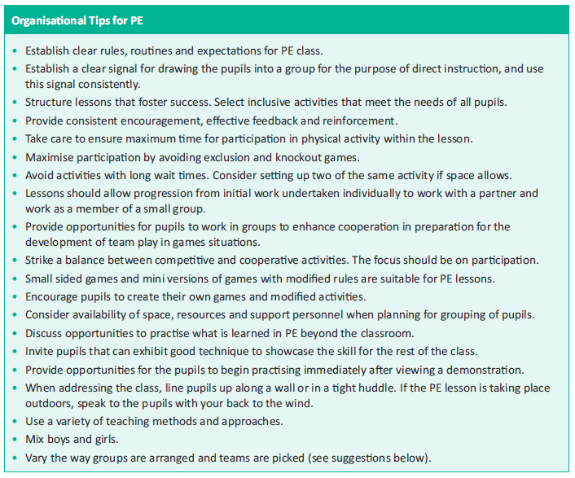

**Active School**

Baltydaniel NS is an Active School. The Active School Flag (ASF) is a Department of Education and Skills initiative supported by Healthy Ireland. The ASF is awarded to schools that strive to achieve a physically educated and physically active school community. The process aims to get more schools, more active, more often. In order to achieve the ASF, we began the process by self-evaluating our current provision across three areas: Physical Education, Physical Activity and Partnerships. We were awarded the ASF in 2015. The flag remains valid for a period of 3 years after which time we will be invited to re-apply. We have applied for the Active Flag in 2022.

Each year, Milford NS will facilitate an Active School Week whereby the discretionary curriculum time for the period in question is used to promote physical activity for all children in the school encompassing as many of the strands of the PE curriculum as possible. This will take place in June. In addition to PE we prioritise physical activity throughout the day during Active Schools Week.

**Active Flag**

Milford school is an Active School, a school that strives to achieve a physically educated and physically active school community.

The Active Flag includes pupils in the decision making process in terms of the provision and promotion of physical activity.

**Amber flag**.

Milford school is actively promoting a culture of change in the promotion of positive well- being in our school community. As physical activity has been linked to improved classroom behaviour, higher academic attainments and emotional well-being, physical activity is actively promoted within the school.

**After School Activities**

* School may provide further opportunities within an extra-curricular programme. This might include preparation for inter-school competitions
* We will ensure that these extra-curricular activities are linked to the PE programme
* Competitions/leagues/games are entered annually which take place during the first and third term of the year. These are generally camogie, hurling and football and Ladies Football.
* Children from Milford participate in the Cork City Sports each year.
* The school does organise a sports day where parents/community/others can be invited to view children’s PE activities

**Code of Ethics**

*(Refer to Milford NS Child Safe Guarding Statement and the Code of Conduct for External Agencies for Sports & the Arts.)*

* If coaches from a local or a national sporting organisation are invited into the school to work with the children as part of their PE class, they will be used to support the class teacher in the implementation of some of the PE curriculum strands in the school. They will not replace the class teacher and ultimate responsibility for the class lies with the class teacher. The class teacher will in turn support the coach on certain occasions when this will lead to maximum benefit for the children in the class.
* Any coaches working in the school context should undergo Garda Vetting and will be expected to adhere to the Code of Ethics of Irish Sport, produced by the Irish Sports Council. ‘Adults interacting with children in sport (referred to as Sports Leaders in this Code) are in a position of trust and influence. They should always ensure that they treat children with integrity and respect and that the self-esteem of children is enhanced. All adult actions in sport should be guided by what is best for the child and carried out in the context of respectful and open relationships. Verbal, physical, emotional or sexual abuse of any kind or threat of such abuse is totally unacceptable within sport, as in society in general.
* If there is a suspected case of child abuse in the class (even if it becomes apparent in the context of a PE class), all teachers will adhere to the Department of Education and Science Child Protection Procedures for Primary and Post-Primary Schools 2017 to be used with the‘Children First National Guidance for the Protection and Welfare of Children (2017) produced for all personnel working with children.



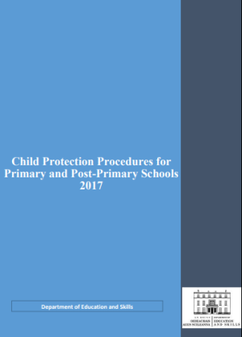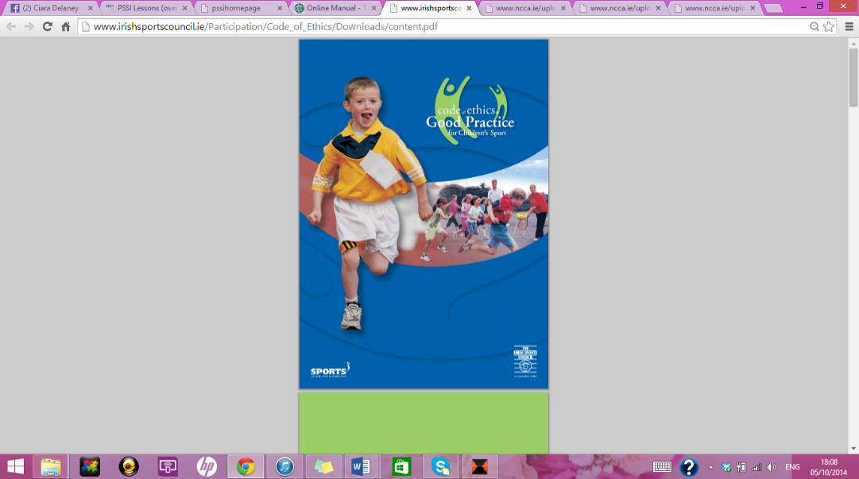

**PE Equipment and ICT (*Refer to pp. 104-105 Teacher Guidelines)***

* Our school has a detailed inventory of equipment and resources available for PE. This list is compiled by the principal, Mr. O’Flynn and is checked and updated at the beginning and end of each school year.
* The equipment is stored in our PE store room in the school. Each teacher has the responsibility to ensure that all equipment is returned to the room after each lesson. Any breakages have to be reported to the post holder as soon as possible. The principal will inspect the room once a month.
* The Principal in consultation with the staff will have the responsibility to purchase the PE equipment for the school and to apply forequipment from different organisations who give free equipment to schools.
* The BOM, on the recommendation of the Principal (informed by the PE post-holder) will sanction a budget for updating PE equipment annually - subject to funds being available. The principal may also request additional funds from the Parents Association.
* In order to ensure a PE rich environment, the school will have dedicated Sports and Active Schools noticeboards and school website with a link for Active School where school and local sporting events will be advertised. The use of pictures and videos will be vital in recording PE activities. The display of these pictures on the sports noticeboard and school website will give an opportunity to children to see themselves and others in action.

**ICT (Refer to p. 101 Teacher Guidelines)**

* In order to ensure a PE rich environment, the school will have a dedicated PE information board where school and local events will be advertised. The use of the school’s digital camera will be vital in recording PE activities. The display of these pictures on the notice board will give an opportunity to children to see themselves and others in action.
* The use of the digital camera as a diagnostic tool for teachers is extremely valuable as children can view their own performances while still involved in a PE lesson. They can make immediate changes to the quality of their movements which in turn will enable them to assess themselves in a more meaningful way. *For example, this is particularly true when investigating the theme of balance in the gymnastics strand.* Use will also be made of a digital video camera from time to time to enable children view their performance of certain activities in the PE classroom. The teachers will initiate discussion of the same with the pupils and field any questions the child may have as to how the quality of their performance could be enhanced.
* Microsoft Office, Ipad, Publishing Software will be necessary in the school and most of the software is loaded on the school computers.
* All internet usage follows the strict guidelines laid down by the school in our Internet Usage Policy. This covers the use of appropriate software and the access to safe websites. Teachers will visit websites prior to children being referred to them and much of the websites will be visited by the teacher and shown to the children through a data projector.
* The staff will make use of Seesaw to allow us assign and see Active Homework throughout the year.

**Health and Safety *(Refer to schools Health and Safety Policy)***

Issues identified as being health and safety issues in a PE context include warm-up at the start of all physical activity, practising in confined spaces, use of equipment, accidents, supervision, activities involving the whole school yard, procedures for dealing with accidents …etc

It is important to acknowledge from the beginning that while the following procedures will eliminate unnecessary hazards they cannot remove all risks due to the physical nature of the subject. When engaging children in PE all members of staff will ensure that the following safety aspects will be taken into consideration

* All children have to wear suitable footwear and clothing during a PE lesson.
* The equipment used will be suitable in size, weight and design to the age, strength and ability of the child and be of good quality and in good repair.
* Children will be taught how to lift and carry all PE equipment safely.
* In all PE lessons, children will warm up and cool down. This develops good practice and the children will return to class relaxed after activity.
* Should an accident occur in the PE lesson we will follow the procedures outlined for other accidents in our Health and Safety policy.
* Best practice is safe practice and the teacher should ensure that the children understand that the rules and procedures are there for their safety.
* We will endeavour to have an appropriate surface for the activities in the PE lesson
* Children will not be forced to do activities they are not physically or psychologically ready for.
* There will be at least one person on staff with a current First Aid qualification and the BOM will fund the course fees. The First Aid Kit is kept in a press in the staffroom and is restocked regularly with items only recommended by First Aid personnel. A second portable kit is also available when children are participating in PE outside the school grounds. The medical conditions of all children are detailed by their parents/guardians on the school enrolment form. These are then transferred to a central file on our Aladdin software system and teachers are made aware of any cases they need to be vigilant of. Their parents/guardians will be contacted in emergency situations and if necessary, their family doctor as outlined on the aforementioned enrolment form. Detailed leaflets are made available to all staff on specific conditions such as asthma, diabetes and allergic reactions etc.

**Individual Teachers’ Planning and Reporting**

The whole school plan and the curriculum documents for PE will lay out the structure and format that teachers will follow in addition to the aims and objectives of the primary school curriculum. While these documents are vital for planning, it is important that teachers do not rely on them exclusively as it is necessary to adapt the PE plan to your own class level and experience. It is vital that all teachers plan individually while at the same time ensuring that their class plans coordinate and feed into the overall school plan.

*Teachers will plan based on the strands and the specific Fundamental Movement Skill as outlined on the yearly timetable. Teachers will select one/two teaching points each week to encourage fundamental movement skill proficiency based on the class level. External providers will be made aware of the FMS to enhance the children’s learning.*

The Cuntas Míosúil will be very relevant in reviewing and developing the school plan for the following years. Once the individual Cuntas Míosúil have been evaluated it should be obvious to the staff which elements of the curriculum were being implemented.

**Staff Development**

Daniel O’ Flynn will take responsibility for monitoring developments in PE, current research, reference books, resource materials and websites dealing with PE. [www.pcsp.ie](http://www.pcsp.ie/), [www.irishprimarype.com](http://www.irishprimarype.com/), [www.activeschoolflag.ie](http://www.activeschoolflag.ie) and [www.pdst.ie](http://www.pdst.ie) have definite links to the curriculum and PE in Ireland. The school has a library of relevant resource material which will aid the teachers in their development and implementation of the PE curriculum and we endeavour to build on it. An inventory of organisations can be found on the Active School website. The resource library will be updated regularly by the post- holder and the Principal. A clear location will be found in the school for this.

The schools intend to contact the PDST for sustained support in P.E.

We will purchase an extra set of Move Well Move often books and continue to make use of this resource pack.

If the need arises, we will ask the Cork/Limerick Education Centre if they can organise a course on a particular area of PE we think we need more training on. The staff members attending extra courses will be encouraged to share their new ideas with the rest of the staff. Like all other areas of the curriculum, time is allocated at each staff meeting for regular updates to all staff on the different areas and initiatives that are taking place inside and outside school eg: Active School Programme.

Teachers can benefit from their interaction with the local sports coaches e.g. G.A.A. who provide coaching in the locality. Any coaches invited into the school will be there to support the teacher with a view to promoting good practice.

**Parental Involvement**

*(Refer to Primary School Curriculum, Your child’s learning, Guidelines for Parents)*

We will ask all parents to support their children to participate in all strands of the PE curriculum. We will ask parents with recognised areas of expertise in the area of PE and/or sport to support us in our efforts if their talents will be of benefit.

In order to implement certain aspects of the PE curriculum and to partake in school sport, we may need the assistance of parents in a supervisory capacity, transporting children to sporting events eg: GAA matches and camogie and helping with supervision etc. Staff are not permitted to transport children to any sporting events.

Parent are required to be Garda Vetted before they are involved in any school activities.

**Community Links**

We are very much aware of the school’s role in the community and we are also conscious of the fact that the expertise of people in the community is an invaluable resource to any school. We link with the community whenever possible.We will also refer to famous sports people from our community and invite suitable people into the school to talk to the children as long as the content is in keeping with the sentiments of the curriculum. If a local team or individual has had a notable victory, they will be invited into the school to share the victory with the local children. Also, when Cork are playing in the football and/or hurling Championship, we will hold a red and white day in celebration where children will be encouraged to dress up in their Cork colours. The school will also be decorated with flags, bunting and children’s art work. There are members of clubs/groups in the community that support the school’s PE programme.

**Review**

**Roles and Responsibilities**

Daniel O’Flynnwill co-ordinate the progress of the plan, encourage and accept feedback on its implementation and report to staff on findings. The plan will be monitored and evaluated every September and as the school year nears an end we can reflect meaningfully on how well the PE programme has been taught and received in the school. The following will be consulted in appraising the PE plan

* Teachers
* Pupils
* Parents
* Post holders
* BOM/DES Inspectorate

Success criteria

. When we are reviewing our plan at the end of the school year, we will take into consideration, the following points;

• The importance of enjoyment and play

• Maximum participation by all children

• The development of skills and understanding

• A balance between competitive and non-competitive activities

• A balance between contact and non-contact activities

• Providing opportunities for achievement for each child

• Providing activities equally suitable for boys and girls Means of assessing the outcomes of the plan include;

• Teacher/parent/community feedback

• Children’s feedback regarding the activity level, enjoyment and skill development of the classes

• Inspectors’ suggestions/report

• Second level feedback

Implementation

(a) Roles and Responsibilities

(b) Timeframe

It will be necessary to review this plan on a regular basis to ensure optimum implementation of the PE curriculum in the school.

(a) Roles and Responsibilities

Those involved in the review are, teachers*, pupils, parents and Post holders.* Co Ordinator of the review will be Mr. O’Flynn

1. Plan will be reviewed in 2025

Ratification and Communication

This policy was ratified by the BoM on 12/01/23

Signed : John Dillon

(Chairperson)

1. Page 10, PE Curriculum, 1999
2.